Tutorial 2 – Star Schemas

PART I: The USELOG Case Study

Description
University Computer Lab's director keeps track of the lab usage, measured by the number of students using the lab. This particular function is very important for budgeting purposes. The computer lab director assigns you the task of developing a small Data Warehouse in which to keep track of the lab usage statistics. The main requirements for this database are to:
- Show the usage numbers by different time periods (e.g. morning, afternoon, night)
- Show the usage numbers by time period (e.g. morning, afternoon, night), by major, and by student's class
- Compare the usage numbers for different majors and semesters (e.g. semester 1, semester 2).
Use the provided database that includes the following tables: USELOG, STUDENT, MAJOR, and CLASS
USELOG contains the student access data
USELOG (Log_Date, Log_Time, Student_ID, Act)

STUDENT is a table containing student data
STUDENT (Student_ID, Sex, Full/Part, Type, Class_ID, Major_Code)

MAJOR is a table containing major data
MAJOR (Major_Name, Major_Code)

CLASS is a table containing class data
CLASS (Class_Description, Class_ID)

Tasks
The above case study has been discussed in the lecture this week. Given the requirements above, complete the following:
- Create a star schema for the USELOG data.
- Define the dimensions and attributes for the USELOG star schema.
- Write the SQL statements for the implementation of the star schema.
The following operational databases have been provided for you:
dw.Class: table that stores information about classification ids and descriptions
dw.Major: table that stores information about major codes and descriptions
dw.Student: table that stores information about students as described above
dw.Uselog: table that stores information about lab usage as described above

You do not need to copy these four tables (dw.Class, dw.Major, dw.Student, and dw.Uselog) into your account. You can just simply use these tables.
- Write the SQL statements to produce the following reports:
  - Show the usage numbers by different time periods (e.g. morning, afternoon, night)
  - Show the usage numbers by time period (e.g. morning, afternoon, night), by major, and by student's class
  - Show the usage numbers for different majors and semesters (e.g. semester 1, semester 2).

Solutions

Tasks: Q1 and Q2: Star Schema

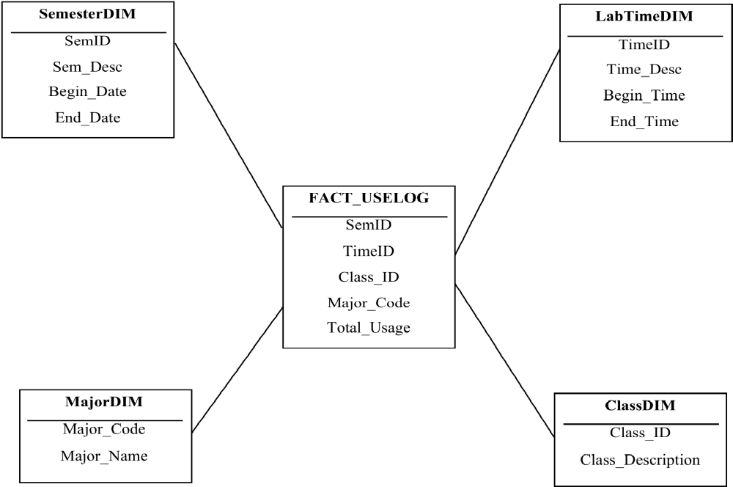

Task: Q3 The SQL to Create the Dimensions and Fact
----------------------------------------------------
-- Step 1: create the dimensions
----------------------------------------------------
-- create semester dimension
DROP TABLE semesterdim CASCADE CONSTRAINTS PURGE;
CREATE TABLE semesterdim (
semid VARCHAR2(10),
sem_desc VARCHAR2(20),
begin_date DATE,
end_date DATE
);

-- create labtime dimension
DROP TABLE labtimedim CASCADE CONSTRAINTS PURGE;
CREATE TABLE labtimedim (
timeid NUMBER,
time_desc VARCHAR2(15),
begin_time DATE,
end_time DATE
);

-- create major dimension
DROP TABLE majordim CASCADE CONSTRAINTS PURGE;
CREATE TABLE majordim AS
SELECT * FROM dw.major;

-- create class dimension
DROP TABLE classdim CASCADE CONSTRAINTS PURGE;
CREATE TABLE classdim AS
SELECT * FROM dw.CLASS;

-- populate semester dimension for Semester 1 and Semester 2
-- (the begin and end date can be changed accoding to the case)
INSERT INTO semesterdim
VALUES ('S1', 'Semester1', TO_DATE('01-JAN', 'DD-MON'),
TO_DATE('15-JUL', 'DD-MON'));
INSERT INTO semesterdim
VALUES ('S2', 'Semester2', TO_DATE('16-JUL', 'DD-MON'),
TO_DATE('31-DEC', 'DD-MON'));

--populate labtime dimension
-- populate labtime dimension for morning, afternoon and night
-- (the begin and end time can be changed according to the case)
INSERT INTO labtimedim
VALUES(1, 'morning', TO_DATE('06:01', 'HH24:MI'),
TO_DATE('12:00', 'HH24:MI'));
INSERT INTO labtimedim
VALUES(2, 'afternoon', TO_DATE('12:01', 'HH24:MI'),
TO_DATE('18:00', 'HH24:MI'));

INSERT INTO labtimedim
VALUES(3, 'night', TO_DATE('18:01', 'HH24:MI'),
TO_DATE('06:00', 'HH24:MI'));

----------------------------------------------------
-- Step 2: create a temp fact table to extract from
-- uselog table
----------------------------------------------------
DROP TABLE temp_fact_uselog CASCADE CONSTRAINTS PURGE;
CREATE TABLE temp_fact_uselog AS
SELECT u.log_date , u.log_time, u.student_id, S.class_id, S.major_code
FROM dw.uselog u, dw.student S
WHERE u.student_id = S.student_id;

-- add a column in the tempfact table to store timeid
-- (cannot directly do this in the tempfact table because
-- log_time was of DATE type and timeid is of NUMBER type).
ALTER TABLE temp_fact_uselog
ADD (timeid NUMBER);

UPDATE temp_fact_uselog
SET timeid = 1
WHERE to_char(log_time, 'HH24:MI') >= '06:01'
AND to_char(log_time, 'HH24:MI') <='12:00';

UPDATE temp_fact_uselog
SET timeid = 2
WHERE to_char(log_time, 'HH24:MI') >= '12:01'
AND to_char(log_time, 'HH24:MI') <='18:00';

-- note that we use OR in the last update statement to
-- include the time between 18:01 and 06:00.
UPDATE temp_fact_uselog
SET timeid = 3
WHERE to_char(log_time, 'HH24:MI') >= '18:01'
OR to_char(log_time, 'HH24:MI') <='06:00';

-- alternatively, you may want to update timeid=3
-- for all other records where the time_id is still empty
-- update temp_fact_uselog
-- set timeid = 3
-- where timeid is NULL;

-- add a column in the temp_fact_uselog table to store semid
-- (cannot directly do this in the test table because
-- log_date was of DATE type and semid is of VARCHAR type.)
ALTER TABLE temp_fact_uselog
ADD (semid VARCHAR2(10));

-- populate the new attribute semid by summarizing
-- the date(log_date)
UPDATE temp_fact_uselog
SET semid = 'S1'
WHERE to_char(log_date, 'MMDD') >= '0101'
AND to_char(log_date, 'MMDD') <= '0715';

UPDATE temp_fact_uselog
SET semid = 'S2'
WHERE to_char(log_date, 'MMDD') >= '0716'
AND to_char(log_date, 'MMDD') <= '1231';

-- Now, create the fact table,
-- make sure to include the TOTAL aggregate.
-- This is an aggregate table of the earlier tempfact table.
DROP TABLE fact_uselog CASCADE CONSTRAINTS PURGE;
CREATE TABLE fact_uselog AS
SELECT T.semid, T.timeid, T.class_id,
T.major_code, COUNT(T.student_id) AS total_usage
FROM temp_fact_uselog T
GROUP BY T.semid, T.timeid, T.class_id, T.major_code;

Task: Q4 The Reports
a) Show the usage numbers by different time periods (e.g. morning, afternoon, night)

SELECT u.timeid, L.time_desc, SUM(u.total_usage) AS usage_numbers
FROM fact_uselog u, labtimedim L
WHERE u.timeid = L.timeid
GROUP BY u.timeid, L.time_desc
ORDER BY u.timeid;

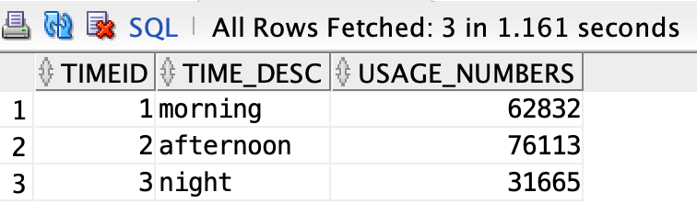

3 rows selected.

b) Show the usage numbers by time period (e.g. morning, afternoon, night), by major, and by student's class)

SELECT u.timeid, L.time_desc, u.major_code, M.major_name, u.class_id,
C.class_description, SUM(u.total_usage) AS usage_numbers
FROM fact_uselog u, labtimedim L, majordim M, classdim C
WHERE u.timeid = L.timeid
AND u.major_code = M.major_code
AND u.class_id = C.class_id
GROUP BY u.timeid, L.time_desc, u.major_code, M.major_name,
u.class_id, C.class_description;

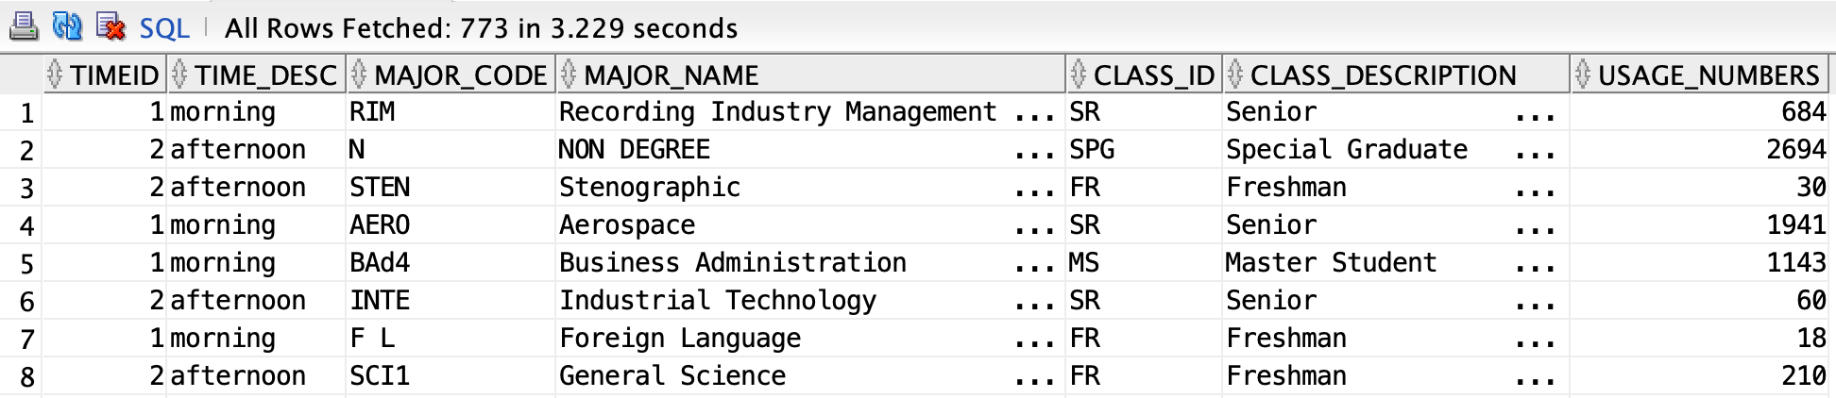

773 rows selected.

c) Show the usage numbers for different majors and semesters (e.g. semester 1, semester 2).

SELECT u.major_code, M.major_name, u.semid, S.sem_desc,
SUM(u.total_usage) AS usage_numbers
FROM fact_uselog u, majordim M, semesterdim S
WHERE u.major_code = M.major_code
AND u.semid = S.semid
GROUP BY u.major_code, M.major_name, u.semid, S.sem_desc
ORDER BY u.major_code;

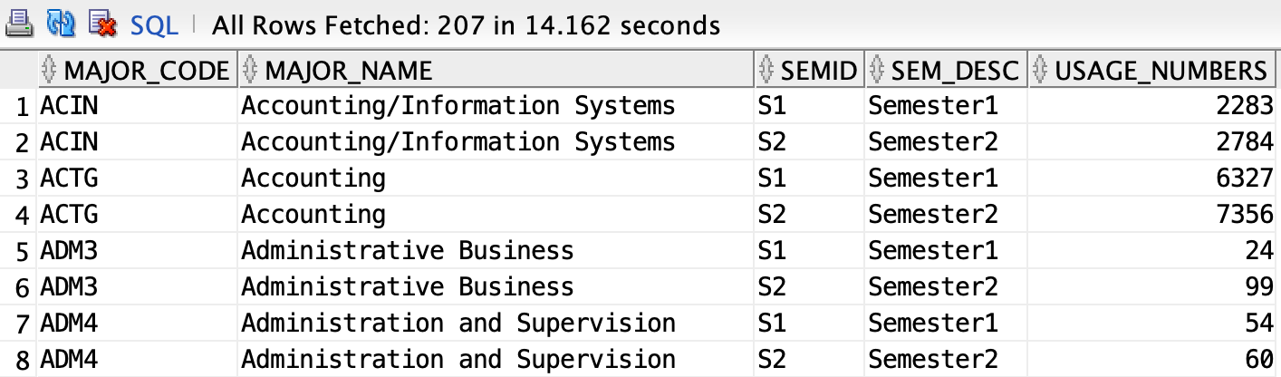

207 rows selected.

PART II: The ROBCOR Aviation Charters Case Study

Description
ROBCOR, Inc. provides “on demand” aviation charters, using a mix of different airplane and airplane types. Because ROBCOR, Inc., has grown rapidly, it has hired you to be its first database manager. Your first and critical assignment is to develop a decision support system to analyze the charter data.

The charter operations manager wants to be able to analyze charter data such as total hours flown, total fuel used, and total revenue (charter distance x model charge per mile). She would also like to be able to drill-down by pilot, airplane model, and time periods. The main requirements for this database are to:
- Show the total revenue each month/year
- Show the total hours flown by each pilot
- Show the total fuel used by each airplane model.

The database currently has the following tables:
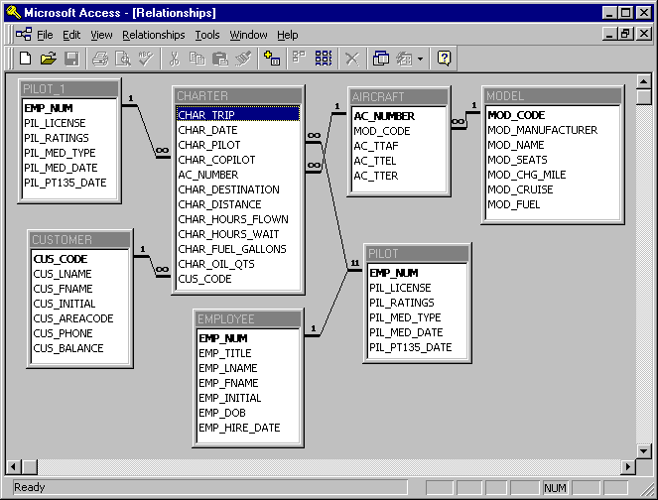

The tables can be copied from the dw account, using:
Select * from dw.<table_name>;
Or
Create Table <your_table_name> As
Select …
From dw.<table_name>
Where …

Given these requirements, complete the following:

- Create a star schema for the charter data.
- Define the dimensions and attributes for the charter operation’s star schema.
- Define the SQL statements for the implementation of the star schema.
- Write the SQL statements to produce the following reports:
  - Show the total revenue each year
  - Show the total hours flown by each pilot
  - Show the total fuel used by each aircraft model

Solutions

Tasks: Q1 and Q2: Star Schema
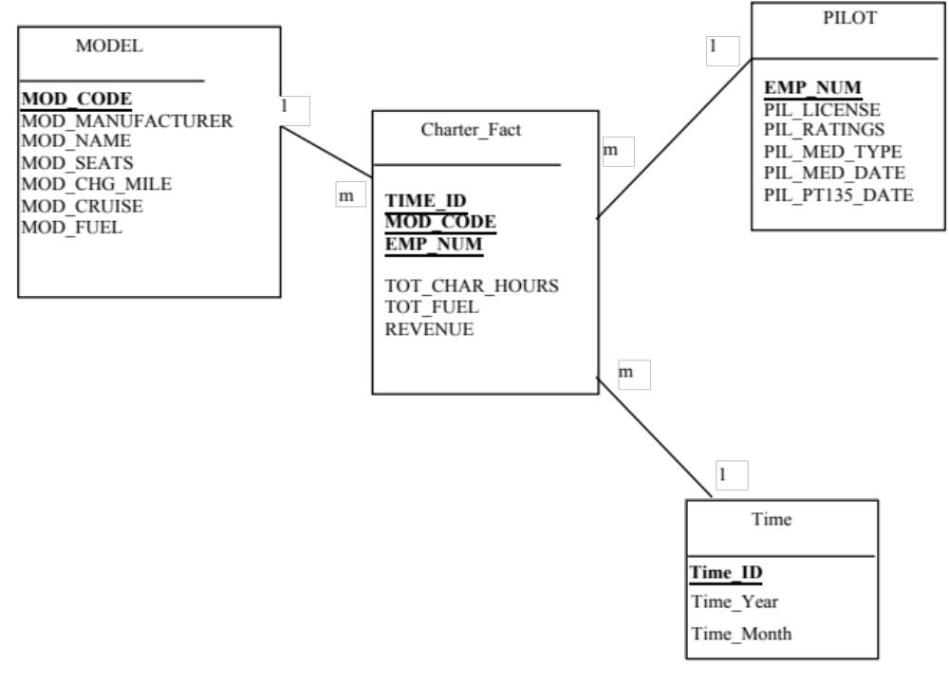

Task: Q3 The SQL to Create the Dimensions and Fact
----------------------------------------------------
-- Step 1: create the dimensions
----------------------------------------------------
--create time dimension
DROP TABLE time CASCADE CONSTRAINTS PURGE;
CREATE TABLE time AS
SELECT DISTINCT to_char(char_date, 'YYYYMM') AS time_id,
to_char(char_date, 'Month') AS time_month,
to_char(char_date, 'YYYY') AS time_year
FROM dw.charter;

--copy model and pilot dimensions
DROP TABLE model CASCADE CONSTRAINTS PURGE;
CREATE TABLE model AS
SELECT * FROM dw.model;

DROP TABLE pilot CASCADE CONSTRAINTS PURGE;
CREATE TABLE pilot AS
SELECT * FROM dw.pilot;

----------------------------------------------------
-- Step 2: create the Charter_fact (the fact table)
----------------------------------------------------
CREATE TABLE charter_fact AS
SELECT C.char_pilot AS emp_num,
M.mod_code,
to_char(C.char_date, 'YYYYMM') AS time_id,
SUM(C.char_hours_flown) AS tot_char_hours,
SUM(C.char_fuel_gallons) AS tot_fuel,
SUM(C.char_distance * M.mod_chg_mile) AS revenue
FROM dw.charter C, dw.MODEL M, dw.aircraft A
WHERE C.ac_number=A.ac_number AND A.mod_code=M.mod_code
GROUP BY C.char_pilot, M.mod_code, to_char(C.char_date, 'YYYYMM');

Task: Q4 The Reports
a. Show the total revenue each year
SELECT T.time_year AS YEAR, SUM(C.revenue) AS total_revenue
FROM charter_fact C, TIME T
WHERE C.time_id = T.time_id
GROUP BY T.time_year
ORDER BY T.time_year;

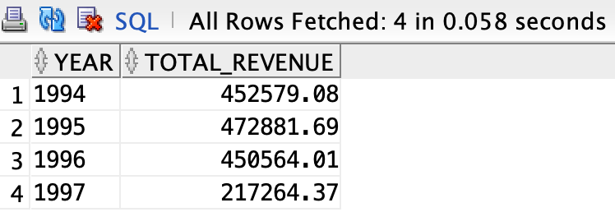
4 rows selected.

b. Show the total hours flown by each pilot
SELECT emp_num, SUM(tot_char_hours) AS total_hours_flown
FROM charter_fact
GROUP BY emp_num
ORDER BY emp_num;

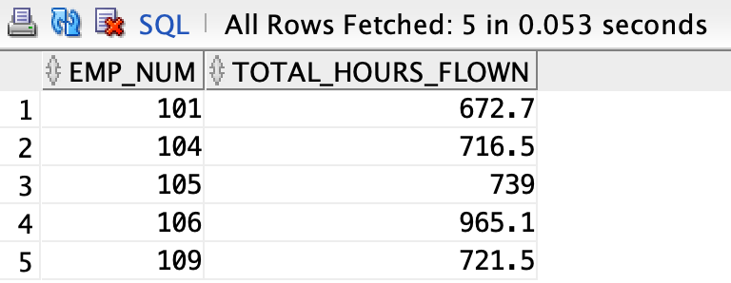
5 rows selected.

c. Show the total fuel used by each aircraft model.

SELECT M.mod_code AS model_code, M.mod_name AS model_name,
SUM(C.tot_fuel) AS total_fuel_used
FROM charter_fact C, MODEL M
WHERE M.mod_code = C.mod_code
GROUP BY M.mod_code, M.mod_name;

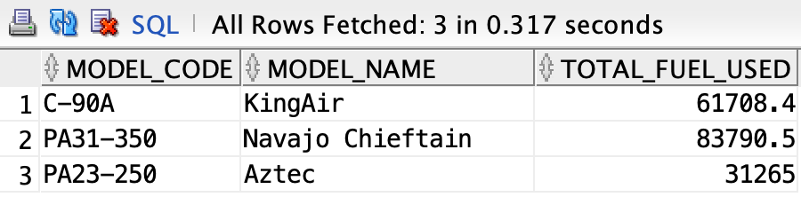
3 rows selected.

